**PAYMENT BILLING SYSTEM**

**Introduction:**

This project is a web based application that concentrates on maintaining the accountant salary and student payment and personal details in an Institute. This application consist of 2 modules namely Admin and Accountant. The Admin is responsible to create, update and delete both student and accountant details. The Accountant is responsible for create, update, and delete student details. The fees detail of student and salary structure of the Accountant is managed by this application.

**Modules:**

There are 2 main modules in this application:

1. Admin module
2. Accountant module
3. **Admin Module:**
   * Admin creates Accountant details.
   * Admin can update and view the Accountant details.
   * Admin is responsible to update and view salary details for Accountant.
   * Admin can view and update Student data.
   * Admin can view Fee report in Excel format.
4. **Accountant Module:**
   * Accountant creates Student Records
   * Accountant can update and view student Details.
   * Accountant is responsible for updating Fee details of student.
   * Accountant can view Fee Report in Excel format.

**Class Diagram:**

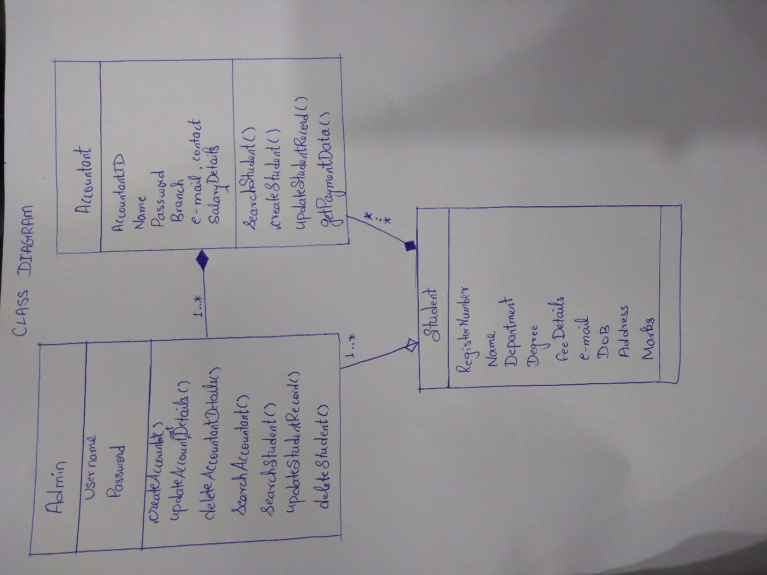

**Validation to be provided:**

1. Client-side validation for basic registration forms.
   * Checking Username
   * Checking password strength.
   * Validating email id and phone numbers, etc.,
2. Server-side validation for preventing creation of duplicate users.

**Database Design:**

1. **Accountant table:**

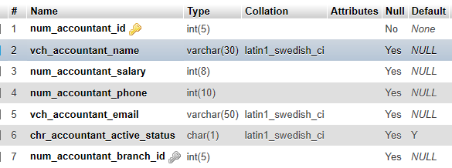

1. **Branch table:**

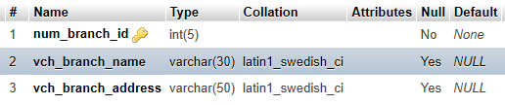

1. **Student table:**

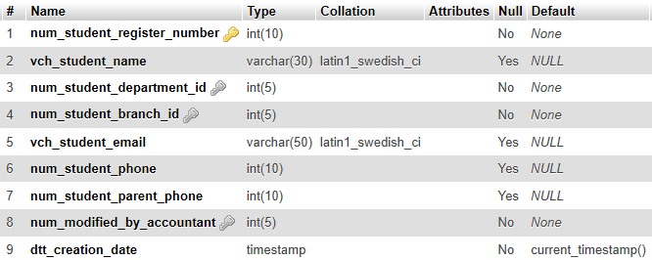

1. **Fee Status table:**

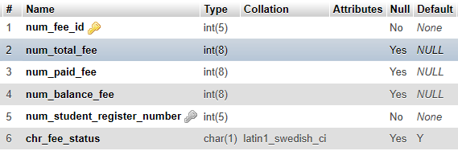

1. **Login table:**

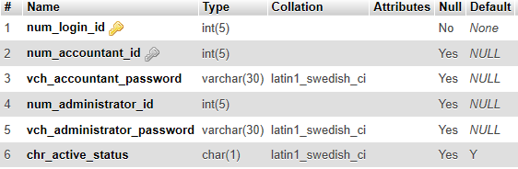

1. **Department table:**

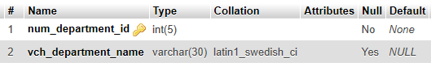

**Tools and Technology used:**

1. **Languages :** Java8, Spring MVC(with Ajax, JSP, JDBC, Servlet)
2. **Server :** Tomcat 8.5
3. **Database :** MySQL
4. **Platform :** Eclipse
5. **Front end :** HTML5, CSS3, JavaScript